UI Wireframes

**Home page**

My Account ->

Register

Login

Shopping Bag

Search Box

Electronics World

ALL Products Electronics HomeWare Special Offers

Hero Image

With button to Shop now

**Shopping Page**

My Account ->

Register

Login

Shopping Bag

Search Box

Electronics World

ALL Products Electronics HomeWare Special Offers

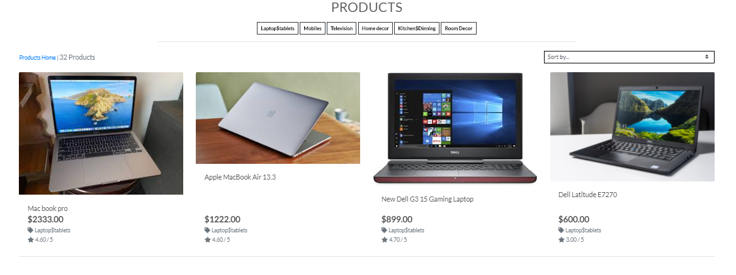

**Register Page**

My Account ->

Register

Login

Shopping Bag

Search Box

Electronics World

ALL Products Electronics HomeWare Special Offers

SIGN UP

Already have an account? Then please sign in.

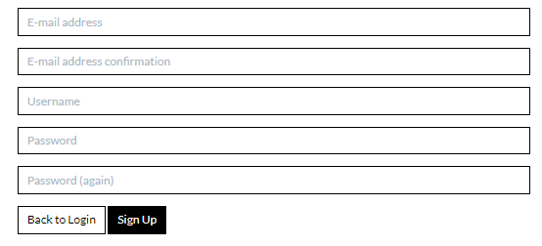

**Login Page**

My Account ->

Register

Login

Shopping Bag

Search Box

Electronics World

ALL Products Electronics HomeWare Special Offers

SIGN IN

If you have not created an account yet, then please sign up first.

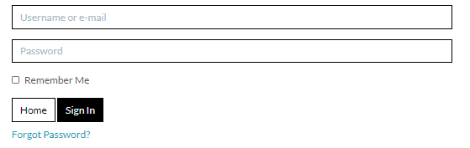

**Shopping bag Page**

My Account ->

Register

Login

Shopping Bag

Search Box

Electronics World

ALL Products Electronics HomeWare Special Offers

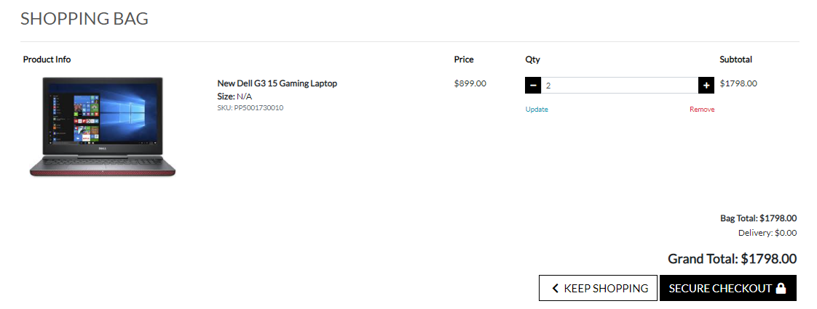

**Checkout Page**

My Account ->

Register

Login

Shopping Bag

Search Box

Electronics World

ALL Products Electronics HomeWare Special Offers

